**Weather API Streaming Project**

Architecture: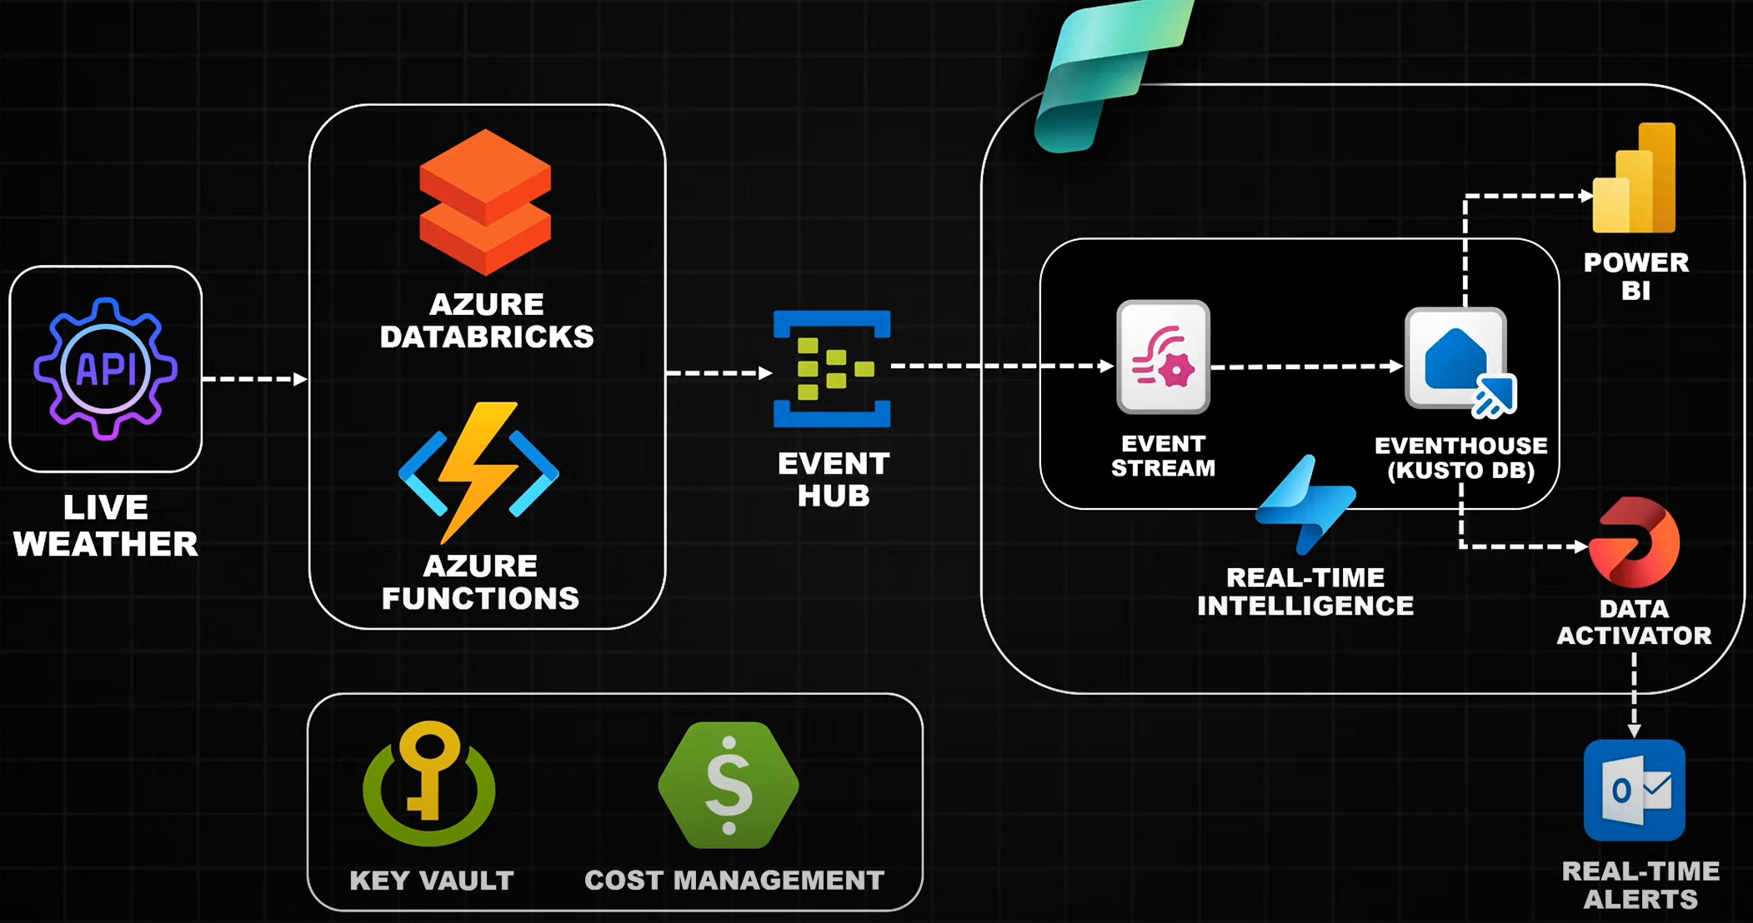

1. Live Weather – using weather api (<https://www.weatherapi.com/> )
   1. Used as Streaming Source, note down API key
2. Creating Azure Resources
   1. Create Resource Group
   2. Create DataBricks
   3. Create Azure Function App (need to select Language, version etc)
   4. Create Event Hub (select pricing tier, and other details)
   5. Create Azure Key vault (select pricing tier, and other details)
      1. Create Secret to store weather API key
   6. Create Microsoft fabric and assign license to Power Bi Service License.
3. DATA INGESTION
   1. **Create Event HUB in “Event HUB Name Space” by clicking on +EventHUB**
      1. Use “Shared Access Policies” under “settings” in event HUB, for connecting to DataBricks from Event HUB
      2. Click on “Add” select Manage/send/Listen
      3. Once it is created, click on that, copy “Primary Connection String”
      4. Go to “key vault” and create new secret for the above key
   2. **Go to Databricks 🡪 click on Launch WorkSpace**
      1. Create a New Compute under “Compute”
   3. **Install “Azure Event Hub Library”** 
      1. Go to Compute
      2. click on compute you created above
      3. libararies
      4. select PyPi
      5. enter library name (**azure-eventhub == 5.15.0))**
   4. **Sending Test Event to Event HUB from Databricks**
      1. See “Test Event to Event HUB” notebook in “ADB” folder
      2. Once event is sent, you can verify it in “Data Explorer -> View Events” in event hub
   5. **Configuring Key Vault to DataBricks**
      1. Go to URL (DB hostname until .net#secrets/createScope) **ex:** [**https://adb-1159450867625697.17.azuredatabricks.net/#secrets/createScope**](https://adb-1159450867625697.17.azuredatabricks.net/#secrets/createScope)
      2. New Page will Open, and need to enter all the details
         1. Scope Name – add any name (key-vault-scope)
         2. Managed Principal – creator/ All workspace users
         3. DNS Name = Vault URL (key vault -> settings -> properties)
         4. Resource ID = Resource ID (key vault -> settings -> properties)
      3. Give “Key vault Secret User” access to “AzureDataBricks” under “key vault -> IAM)
         1. Code is in “Test Event to Even HUB using Key Vault” in “ADB” folder
   6. **Weather API testing in DB (“3. Connecting to weather API” notebook)**
   7. **Developing code to get all the required weather fields (“4. Weather API to get current forecast and alerts” notebook)**
   8. **Writing API data to Event HUB (“7. sending API data for every 30 sec” notebook)**
4. **Use the Function app to connect to DataBricks**
   1. **Install Visual Studio code**
   2. **Install “Azure Functions” extension**
   3. **Create “Azure Function App”**
      1. **Select folder in local system**
      2. **Select Language (Python)**
      3. **Select runtime**
      4. **Select “Timer Trigger”**
      5. **Give Name to function app**
      6. **Enter CRON expression to run for every 30 sec (/*30 * * * * *)**
      7. **Click on “current window” to create project**
   4. **Requirements.txt should be having all the libraries (azure.events, azure.identity,azure.eventhub, zure.keyvault.secrets) which are using in the project**
   5. **Open “function-app.py” file**
      1. **Connecting event hub and function app (to push the events)**
         1. **Enabling Identity of Function App**
            1. **Go to function app**
            2. **Go to setting 🡪 identity 🡪 select “yes” 🡪 click on “save”**
         2. **Giving access to Event HUB using above identity**
            1. **Go to Event HUB Name Space**
            2. **Go to Event HUB**
            3. **Click on IAM**
            4. **Click on +Add**
            5. **Select “Azure Event Hubs Data Sender” role**
            6. **Select “managed identity”**
            7. **Click on “+select Member”**

**Select “Subscription”**

**Select “Function App” under “Managed Identity”**

**Select “Function App name”**

**Click on “select”**

* + - * 1. **Click on “Review+Assign”**
    1. **Connecting function app and key-vault for reading “secrets”**
       1. **Go to “Key Vault”**
       2. **Click on “IAM”**
       3. **Click “+Add Role Assignment”**
       4. **Select “Azure key Vault Secret User”**
       5. **Select “Managed Idenity”**
       6. **Select “+select Member”**
          1. **Select subscription**
          2. **Select “function app” in “Managed Identity”**
          3. **Select correct “Function app name”**
          4. **Click on “select”**
       7. **Click on “Review+Assign”**
    2. **Once code is written in “VS Code”**
       1. **Go to “Azure Extension”**
       2. **Select “Local Project”**
       3. **Click on “Deploy” icon beside “Local Project”**
       4. **Select “function app name”**
       5. **Select “Deploy”**